Thank you for your interest in being a Customer Service Advisor at Macrobert Arts Centre. In this pack, you’ll find out more about Macrobert, the role and some of the skills & qualities we think are important.

**Applicants must have a degree of availability for daytime & evening shifts throughout each week including weekends and around Xmas & New Year.**

**Timeline:**

**Wednesday 11 September 2024 - 12 noon Deadline for application submission**

**Friday 13 September 2024 – time TBA Interviews at Macrobert Arts Centre**

**Week beginning 16 September 2024 Start Date**

Only through a diversity of voices can we create an arts sector that is representative and open to all. Our ambition is to embed equalities practice in our everyday thinking, in every part of the organisation and we actively encourage applications from all sectors of our community. The Equal Opportunities Monitoring Form is for statistical purposes only and is submitted separately from your application then destroyed once the data has been collated.

Yours faithfully,  
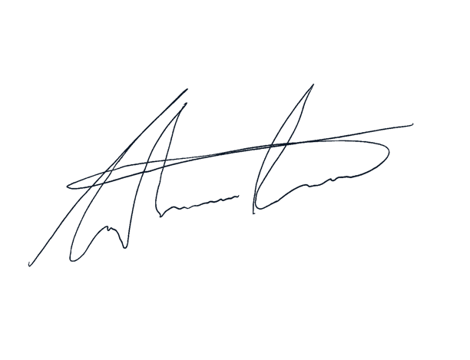

Grahame Reid

Deputy Director – Film Programme and Customer Services

**Macrobert Arts Centre is a cultural hub for Stirling, Forth Valley and Scotland.**

We host a rich mix of live performance, a curated cinema programme, exhibitions and an extensive creative activities programme, working with and for communities across Forth Valley.

Macrobert’s facilities include; a 480 main stage theatre with full flying capability and an orchestra pit which easily transitions to a cinema; a dedicated cinema with 4K projection and the latest Dolby sound, seating 138; an 80 seat studio for smaller scale live performance and more intimate film screenings; and exhibitions spaces. There is a licenced kiosk and a café bar serving refreshments and light meals.

· We believe in the power of the arts to stimulate conversation, to bring people together, to challenge preconceptions and to share worldviews: in short, to make the world a better place.

· We believe in supporting creative people and ideas, to build a creative sector that is more vibrant, nourishing and sustainable.

· We believe that an arts centre should be for everyone.

We recognise the environmental impacts arising from our operation and are working to embed sustainability in the heart of our business practice. We expect everyone at Macrobert to play their part in this.

Find out more about who we are, what we do and how we do it on our website:

<https://www.macrobertartscentre.org/>

and in this report:

<https://issuu.com/macrobertartscentre/docs/macrobert-annualreport-web/64>

|  |  |
| --- | --- |
| **Job title:** | Customer Service Advisor |
| **Work Area:** | Front of House |
| **Accountable to:** | Front of House Manager & Deputy Front of House Managers |
| **Responsible for:** | Delivery of duties |
| **Hours:** | Part Time: likely 10-15 hours per week usually across 3 days based at Macrobert Arts Centre. |
| **Hourly Rate:** | Living Wage - £12.00 per hour |
| **Key relationships** | Front of House colleagues, Technical staff, Macrobert Management staff. |
| **Organisational Standards** | We have organisational standards covering these main areas which all staff are expected to adhere to:  · Standard 1 – High performing team  · Standard 2 – Customer service excellence  · Standard 3 – Safety first |
| **Job Role and Description** | As a Customer Service Advisor at Macrobert Arts Centre, you will play a crucial role in providing excellent customer service and ensuring the safety and comfort of our patrons during events and performances. Your primary responsibilities will include welcoming customers, processing ticket sales, assisting with inquiries, monitoring audience behaviour, and maintaining the cleanliness and safety of public areas. This role requires a friendly and confident demeanour, strong interpersonal skills, and a passion for the arts. |

The primary purpose of this post is to welcome customers and ensure their safety and comfort at all times, the post holder will be a first point of contact for the public.

**Principal Duties and Responsibilities:**

* **Customer Service:** Deliver outstanding customer service by greeting and assisting patrons in a professional and courteous manner. Address general inquiries and provide information about events and performances.
* **Ticket Sales**: Process ticket sales through various channels, including in-person, phone, and email orders, ensuring accuracy and adherence to established procedures.
* **Safety and Compliance**: Ensure compliance with relevant legislation, regulations, and guidelines, including safety protocols and evacuation procedures. Ensure evacuation routes and fire exits are always kept clear.
* **Seating Assistance:** Check the validity of tickets, guide patrons to their seats, and assist with any seating-related issues during performances and screenings.
* **Audience Monitoring:** Monitor the audience during events to identify and address any disruptions or issues promptly, maintaining a pleasant and respectful atmosphere.
* **Kiosk Sales:** Handle kiosk sales, including alcoholic drinks and merchandise, ensuring proper stock rotation and inventory management.
* **Cleanliness and Maintenance:** Maintain the cleanliness and tidiness of all public areas, performing cleaning duties as requested by the Duty Manager.
* **Team Collaboration:** Work cooperatively as part of a team to provide seamless service and support each other during busy periods or emergencies.
* **Additional Tasks:** Be willing to carry out any other tasks assigned by the Duty Manager or Front of House Manager that are appropriate to the role.

**Additional information:**

• The role involves working in dimly lit conditions and standing for extended periods.

• Some manual handling tasks will be required.

• Regular attendance at Macrobert Arts Centre events is expected, with complimentary tickets provided to staff.

**Person Specification**

The successful candidate will need to be able to demonstrate how they satisfy the Essential and Desirable criteria.

|  |  |  |
| --- | --- | --- |
| **Personal Qualities and Interests** | **Importance** | **Assessment method** |
| Friendly and confident with a smart appearance | Essential | Interview |
| Commitment to delivering high standards of customer care | Essential | Application & Interview |
| The ability to work flexibly, efficiently and with good humour under pressure | Essential | Interview |
| Interest in and passion for the arts | Desirable | Application & Interview |
| **Experience & Training** |  |  |
| Previous experience in customer-facing roles or customer care | Essential | Application |
| Familiarity with cash handling procedures | Desirable | Application & Interview |
| Experience in a busy arts environment | Desirable | Application & Interview |
| Experience in welcoming customers with additional access requirements (e.g., Disabilities, Dementia, Autism) | Desirable | Application & Interview |
| First Aid training | Desirable | Application |
| **Knowledge and understanding** |  |  |
| Understanding of and commitment to Equality and Access | Desirable | Application & Interview |
| **Skills** |  |  |
| Strong team player with excellent communication and interpersonal skills | Essential | Referee & interview |
| Ability to interact professionally and courteously with people of all ages and backgrounds | Essential | Referee & interview |
| Articulate with proven interpersonal and communication skills | Desirable | Referee & interview |
| **Additional Employment requirements** |  |  |
| Flexibility to work various shifts, including weekdays, weekends, evenings, and holidays | Essential | Application |

Macrobert Arts Centre has responsibilities in respect of users and applicants are required to disclose any criminal convictions. If you have any criminal convictions which are not spent (in terms of the Rehabilitation of Offenders Act) details should be given in your application together with a statement that you have spent conviction/s if this is the case. Applicants who have spent convictions and are short-listed for the vacancy will be required to make a full declaration of these later. The relevance of any conviction to the appointment sought would be carefully considered by the appointing committee.

Applicants should state their nationality (this is required for work permit purposes only).

**All members of the Front of House team need to exercise a high degree of versatility and flexibility and considerable evening and weekend work is required.**

**This is a permanent position that includes a six-month probationary period. This is a part time post with no set hours, however hours are likely to be around 10-15 per week across 3 days with additional hours available during busy periods.**

**The hourly rate of pay will be £12.00 and shift allocation will consider experience and availability, managed by the Front of House Manager.**

**Interviews will be held on Friday 13 September 2024, if you have not been contacted by this date your application has been unsuccessful in this instance**