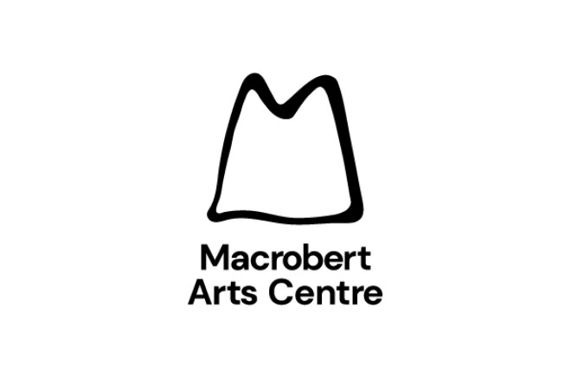

Transport Subsidy Form

This is only available to any school & nursery groups of 20 or more and is only available to those in the Forth Valley area. This scheme will refund a maximum amount of £200 of your coach hire cost. Limited funds are available and applications will only be considered on a first come basis.

Please fill in all details below and return to Macrobert Arts Centre along with a copy of your coach hire invoice and a receipt on payment.

This request should be sent to macrobert at the address below within one month of your visit. Late requests / incomplete applications may not be considered.

Organisation & Performance Details
Contact Name:
Organisation: |  |  |  |  | Local Authority:
Address: |  |  |  |  | Postcode:
Tel: |  |  |  |  | Email:
Performance: |  |  | Date: |  |  |  | Time:

Transport Requested

Amount Requested: £
To enable a quick reimbursement please supply your bank details:

Bank Name:
Sort Code: |  |  |  | - -

Account Number:
Please return to:  Transport Subsidy  Macrobert Arts Centre  University of Stirling  FK9 4LA |  |  |  | Macrobert Use:  Patron Number:  Date:  Performance Name:  No. of Seats:  Method of Payment:  SAP Ref:

